**2. Create EKS Private Node Group**

--- **Reference** - <https://github.com/stacksimplify/aws-eks-kubernetes-masterclass/tree/master/07-ELB-Classic-and-Network-LoadBalancers/07-01-Create-EKS-Private-NodeGroup>

**Introduction**

--- We are going to create a node group in VPC Private Subnets

--- We are going to deploy workloads on the private node group wherein workloads will be running private subnets and load balancer gets created in public subnet and accessible via internet.

**Delete existing Public Node Group in EKS Cluster**

**# Get NodeGroups in a EKS Cluster**

--- **eksctl get nodegroup --cluster=<Cluster-Name>**

--- **eksctl get nodegroup --cluster=eksdemo1**

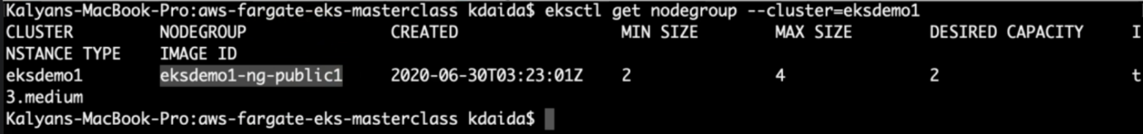

**# Delete Node Group - Replace nodegroup name and cluster name**

--- **eksctl delete nodegroup <NodeGroup-Name> --cluster <Cluster-Name>**

--- **eksctl delete nodegroup eksdemo1-ng-public1 --cluster eksdemo1**

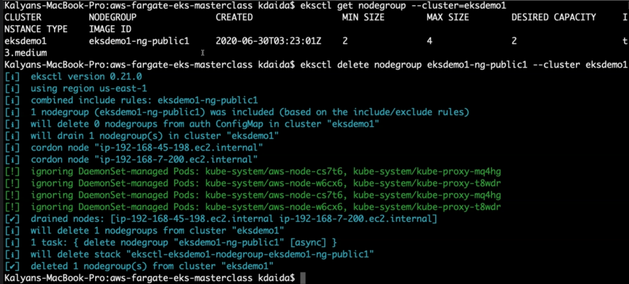

**Create EKS Node Group in Private Subnets**

--- Create Private Node Group in a Cluster

--- Key option for the command is --node-private-networking

eksctl create nodegroup --cluster=eksdemo1 \

                        --region=us-east-1 \

                        --name=eksdemo1-ng-private1 \

                        --node-type=t3.medium \

                        --nodes-min=2 \

                        --nodes-max=4 \

                        --node-volume-size=20 \

                        --ssh-access \

                        --ssh-public-key=kube-demo \

                        --managed \

                        --asg-access \

                        --external-dns-access \

                        --full-ecr-access \

                        --appmesh-access \

                        --alb-ingress-access \

                        --node-private-networking

--- **note** -- **node-private-networking** – this is added parameter. Normally it takes 2 or 3 minutes to creates worker nodes.

**Verify if Node Group created in Private Subnets**

--- Verify External IP Address for Worker Nodes

--- External IP Address should be none if our Worker Nodes created in Private Subnets

--- **kubectl get nodes -o wide**

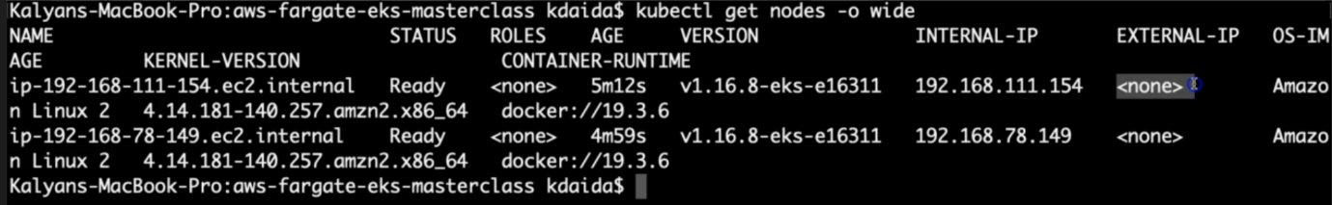

--- **note** – this is one does not have external ip. This confirms that our node group has been created in a private subnet.

**Subnet Route Table Verification - Outbound Traffic goes via NAT Gateway**

--- Verify the node group subnet routes to ensure it created in private subnets

--- Go to Services -> EKS -> eksdemo -> eksdemo1-ng1-private

--- Click on Associated subnet in Details tab

--- Click on Route Table Tab.

--- We should see that internet route via NAT Gateway (0.0.0.0/0 -> nat-xxxxxxxx)

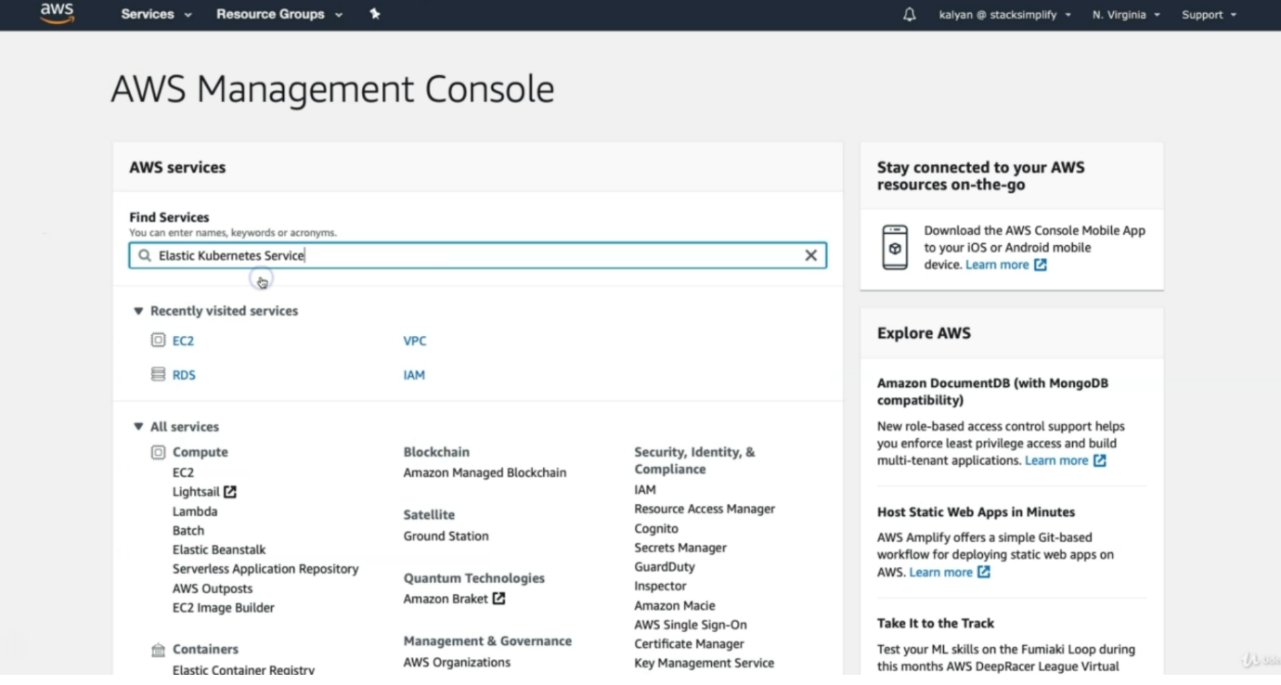

--- search for Elastic kubernetes service

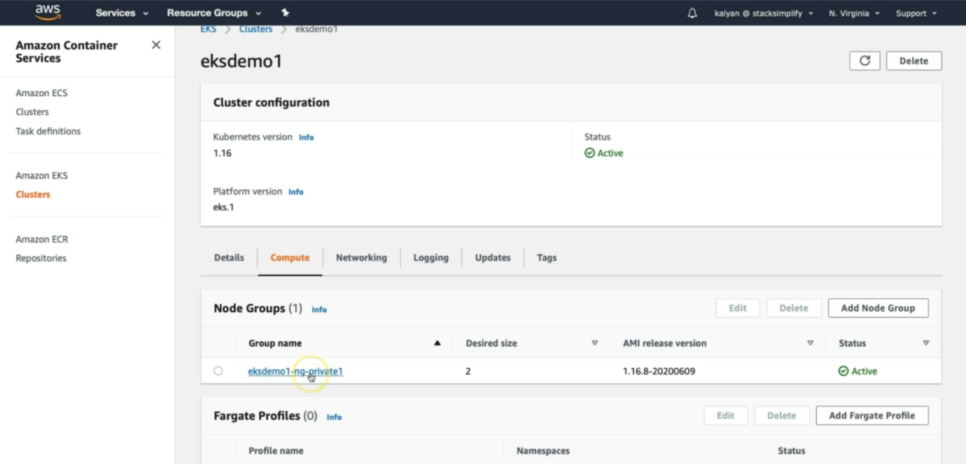

--- click on our cluster name. 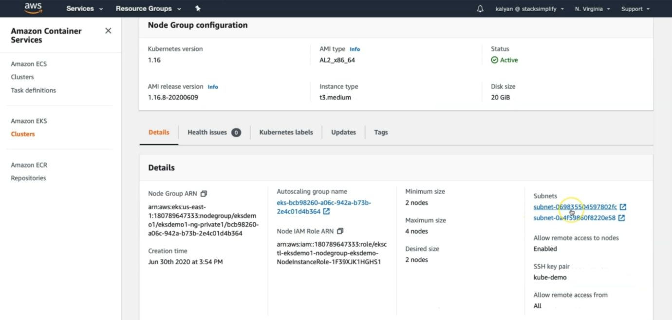

--- click on details, under details you will find subnets.

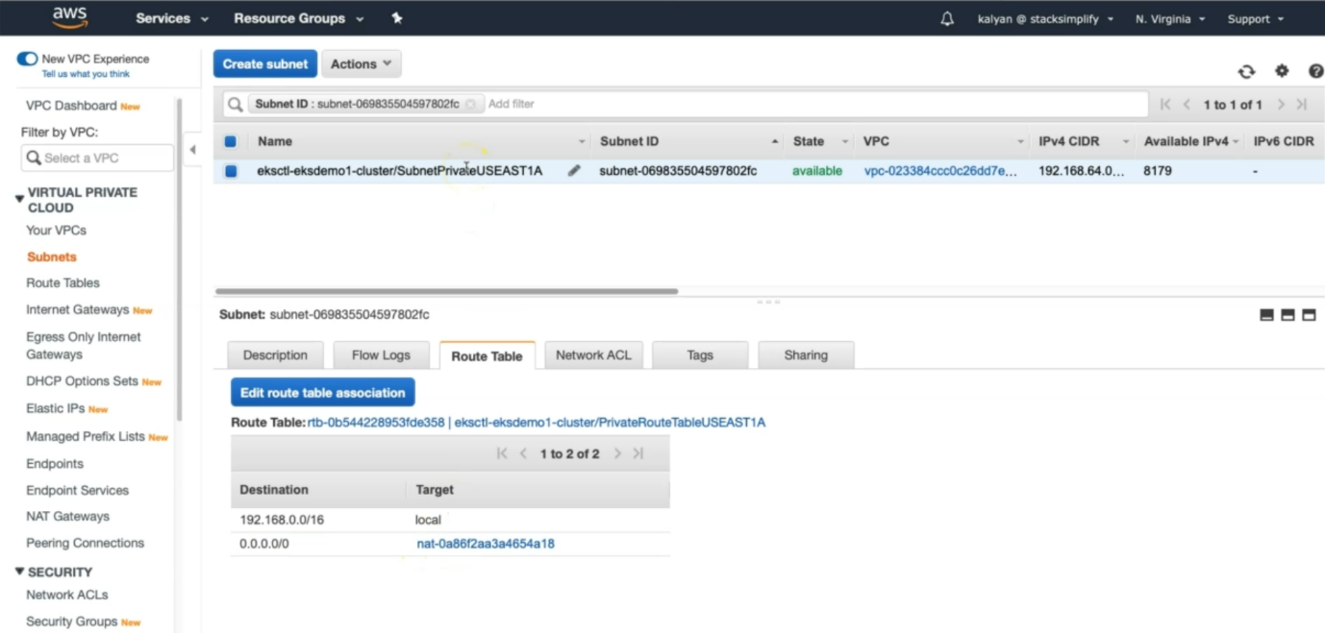

--- here you can see that the traffic goes via nat gateway.

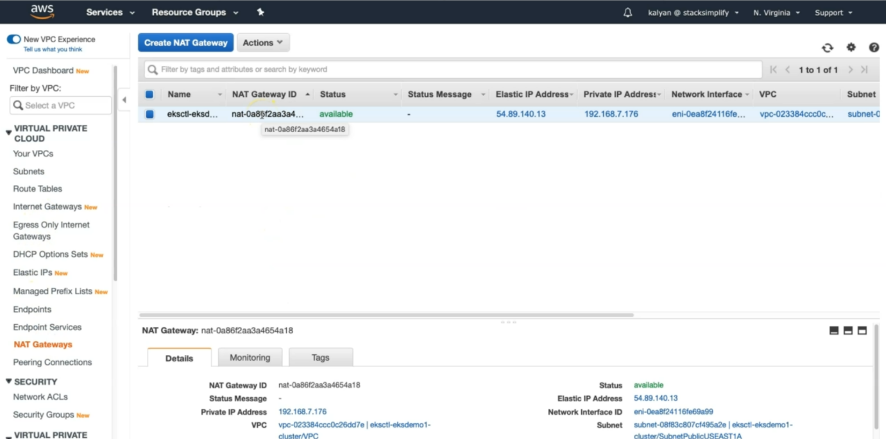

--- you can directly go to nat gateway to verify the above.